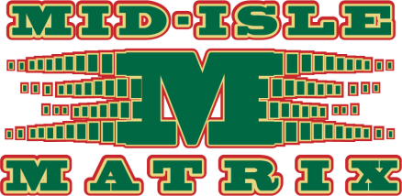

Mid-Isle Matrix AAA Hockey

To: Potential Player Sponsor
Re: Mid-Isle Matrix AAA Hockey Sponsorship

The Matrix AAA Zone was established for the purpose of assuring youth play at the level in which their development skill allows.

The Mid-Isle Matrix Association is in its 9th year of AAA hockey for players aged 9-17. We will be icing teams of the Atom, Peewee, Bantam, and Midget AAA levels. All players will be chosen from our zone consisting of Kensington Minor Hockey Association, North River Minor Hockey Association, Southside Minor Hockey, and North Rustico Minor Hockey Association.

As a Matrix player, I am asking for your support to help my participation at the AAA level up to a maximum of $200.00. Your sponsorship will be used to offset registration cost, which will allow me to attend practice and games throughout Prince Edward Island and to also attend tournaments in Atlantic Canada. You will receive acknowledgement through our game programs, jersey sponsor bars and on our team website. This signed letter by myself is your official receipt. Checks should be made payable to the PLAYER of the Mid-Isle Matrix AAA hockey team.

For any further information, please do not hesitate to contact any of our Mid-Isle Matrix board members.

Thank you for your consideration and involvement in youth sports.

Player’s Signature Team

SPONSORSHIP INFORMATION – Return to team manager for acknowledgements

Sponsor/Company Name_________________________________________________________________

Address_______________________________________________________________________________

City_________________________Prov___________________ Postal Code________________________

Phone #______________________

Email________________________________________________________________________________

Player sponsoring ______________________________________________________________________

